**ANALYSING THE PERFORMANCE & EFFICIENCY OF THE RADISSON HOTELS USING DATA VISUALIZATION TECHNIQUES**

1. **INTRODUCTION:**
   1. **Overview**

* **The hotel Industry is a broad category of businesses that provide lodging services for travellers and tourists.**
* **This can include a wide range of establishments, from luxury resorts tto budget-friendly motels, as well as extended stay hotels, boutique hotels, and more.**
* **Hotels can be found in nearly every corner of the world, and are often a major component of the tourism and travel industry in a given area.**
* **Radisson owns multiple five – star hotels across india.**
* **They have been in the hospitality industry for the past 100 years.**
* **Due to strategic moves from other competitors and ineffective decision- making in management, Radisson is losing its market share and revenue in the luxury/business hotels category.**
* **As a strategic move, the managing director of Radisson wanted to incorporate Business and Data Intelligence in order to regain their market share and revenue.**
* **Our task is create an analytics dashboard & story to provide them insights to make better business decisions.**
  1. **Purpose**
* **Your share market and revenue will be increased.**

1. **Problem Definition & Design Thinking**
   1. **Empathy map**

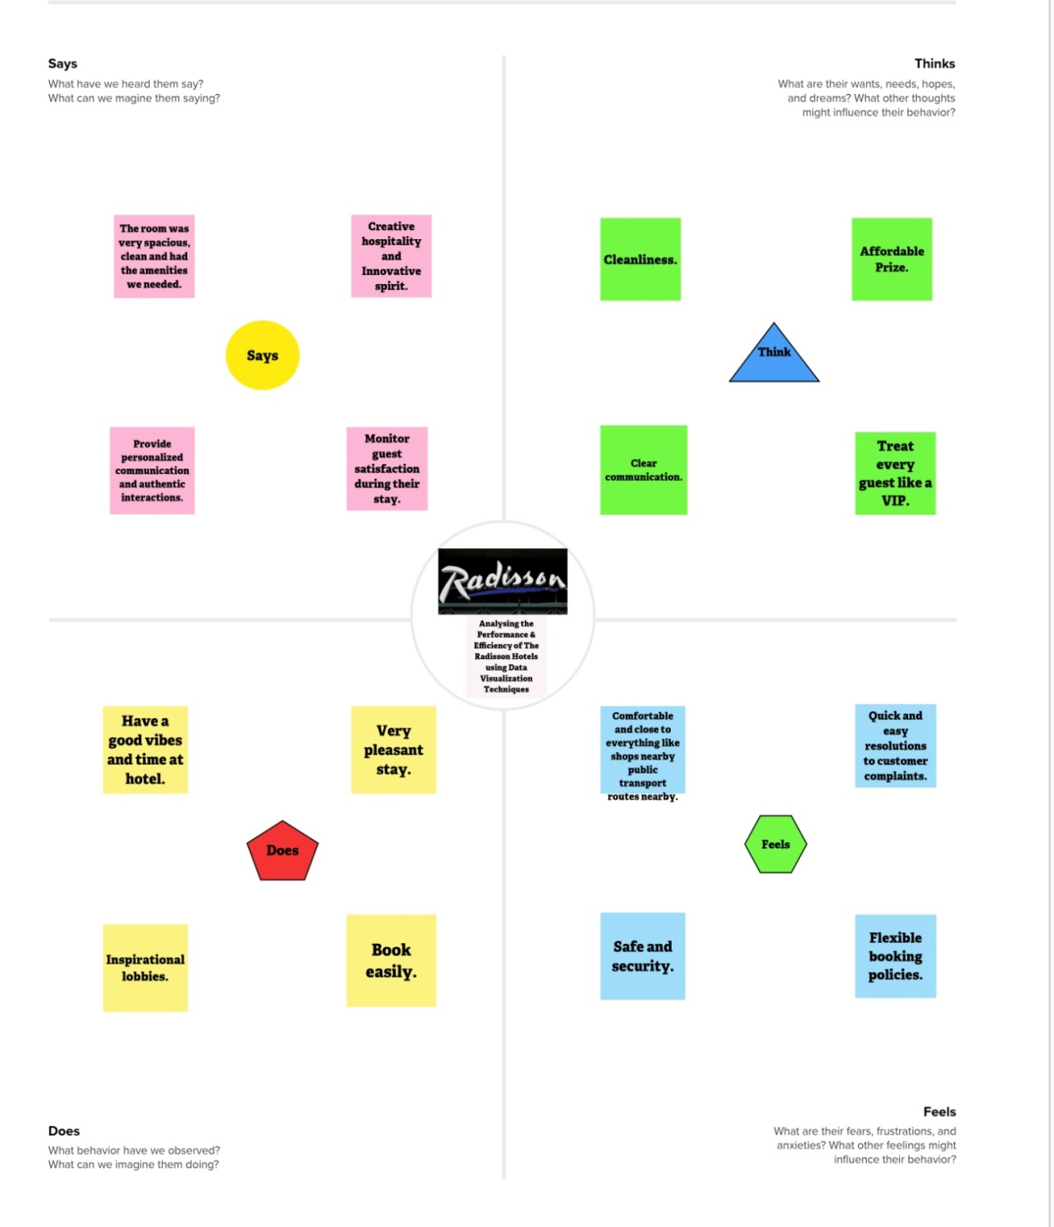

* 1. **Ideation & Brainstorming Map**

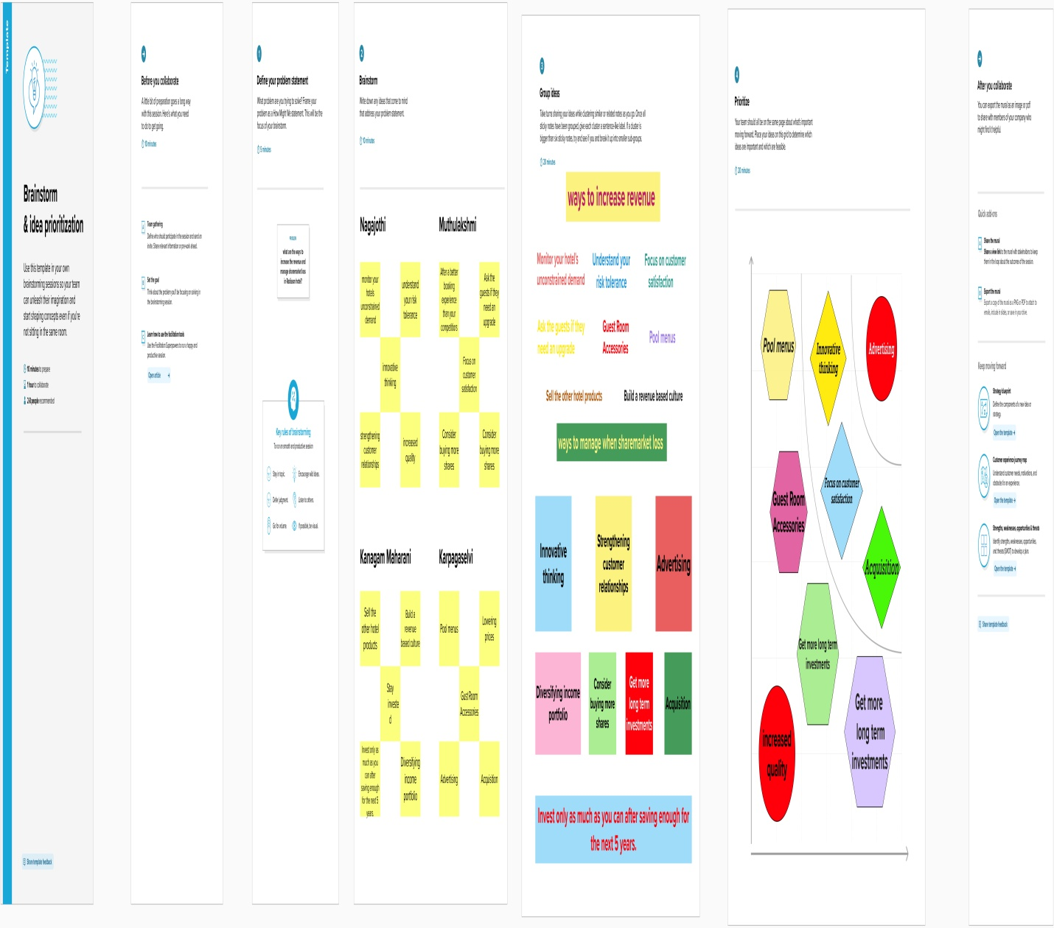

1. **RESULT**

**3.1 STORY**

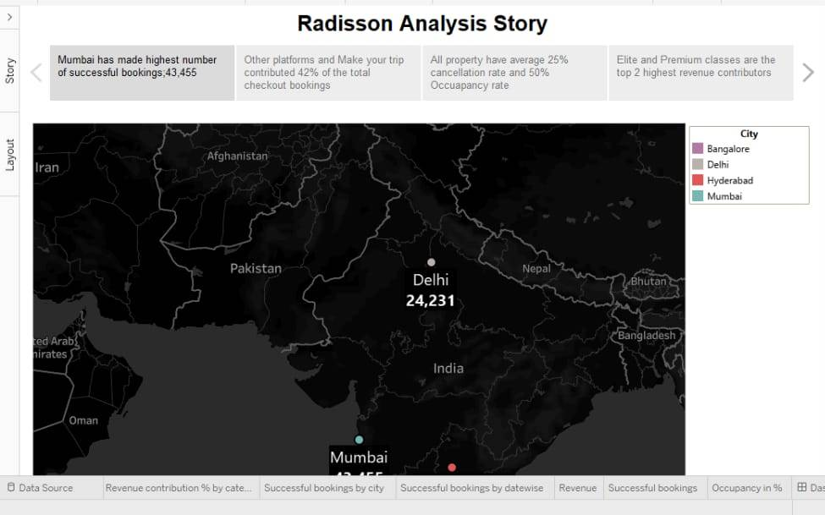

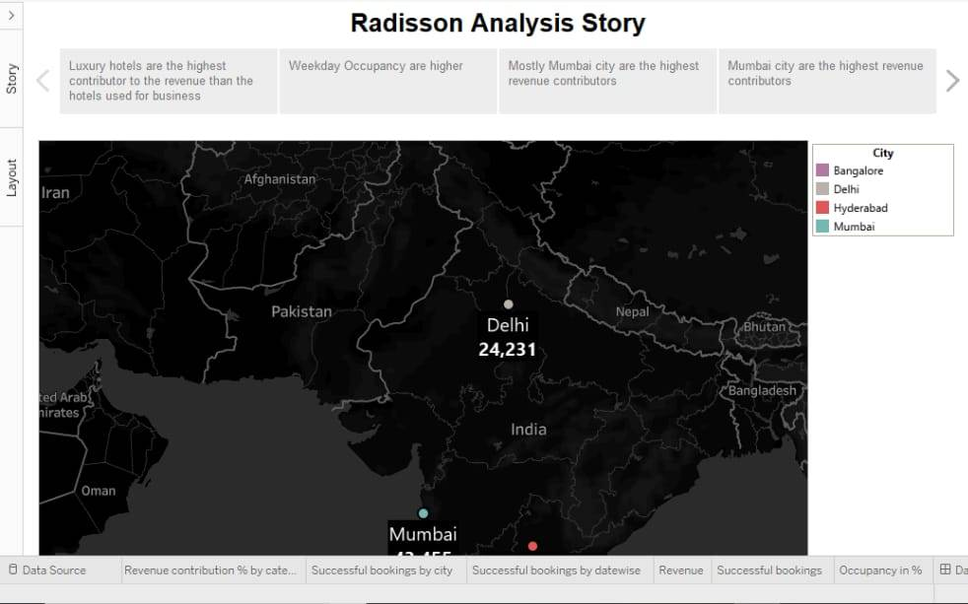

**3.2 DASHBOARD**

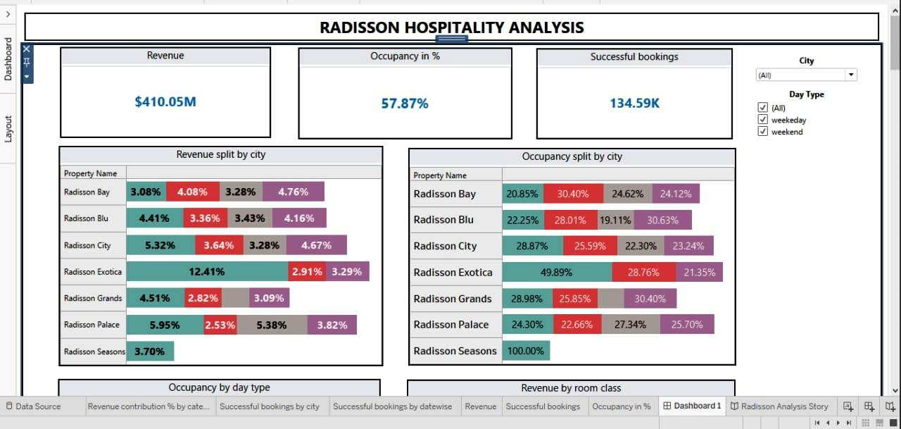

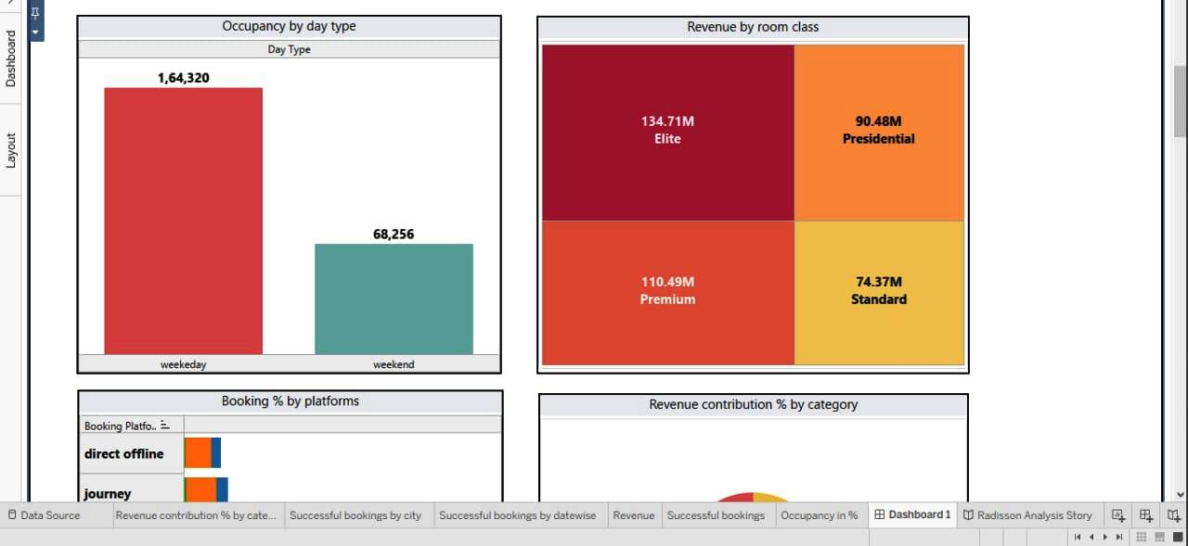

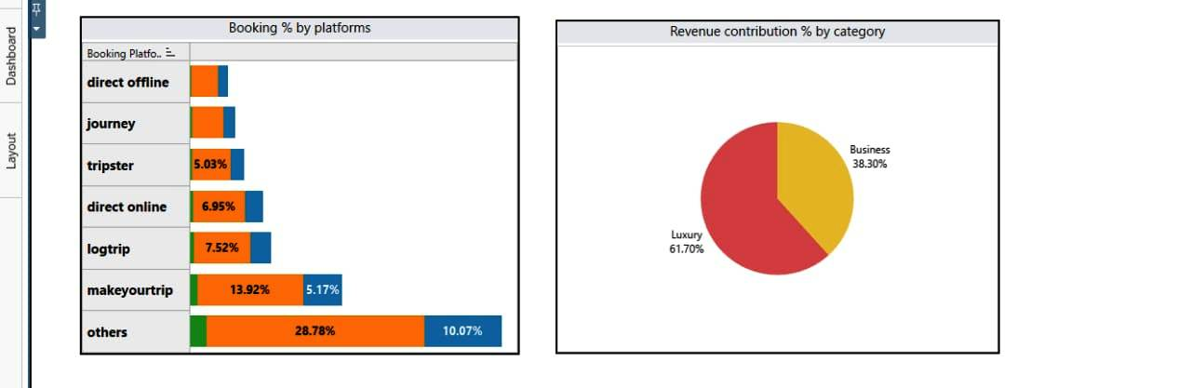

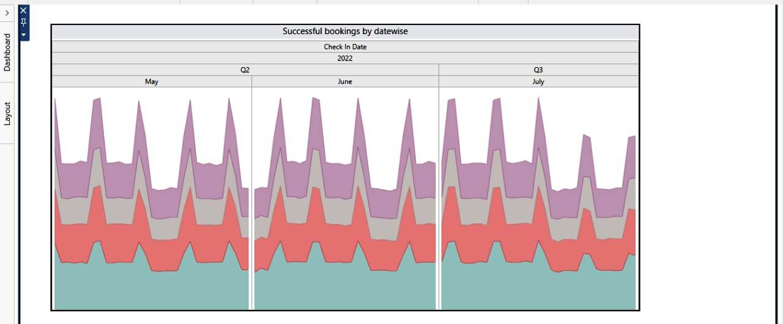

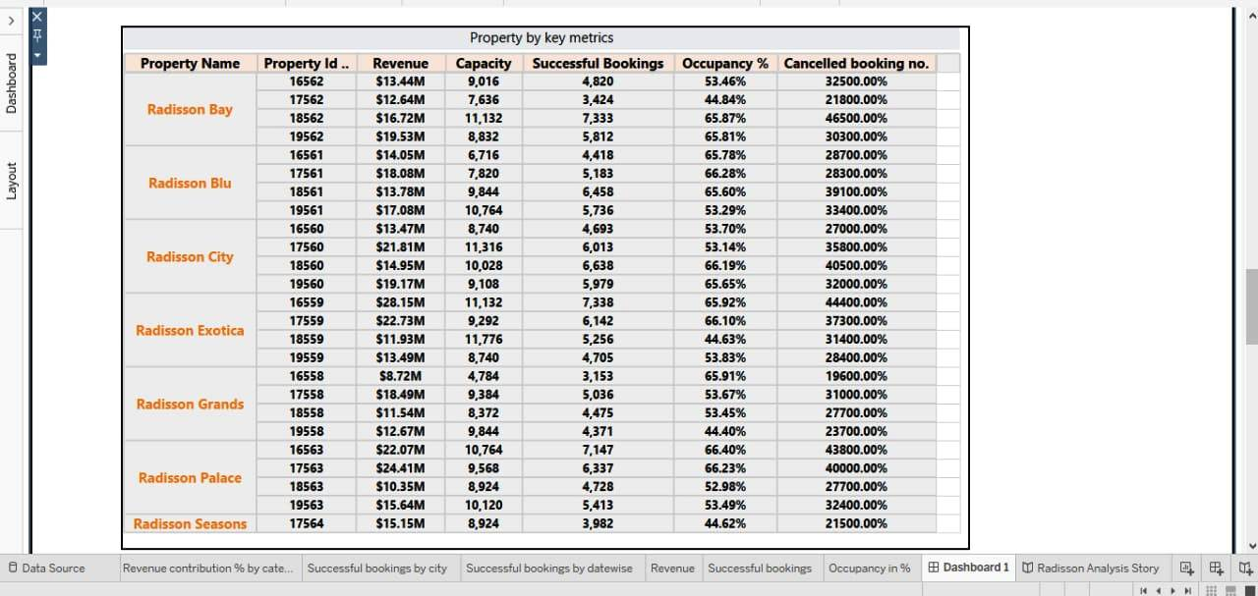

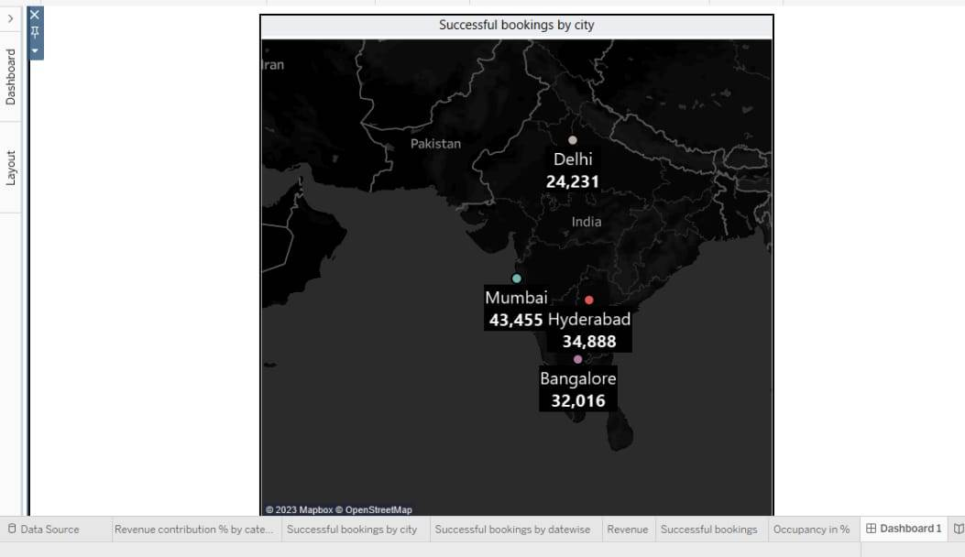

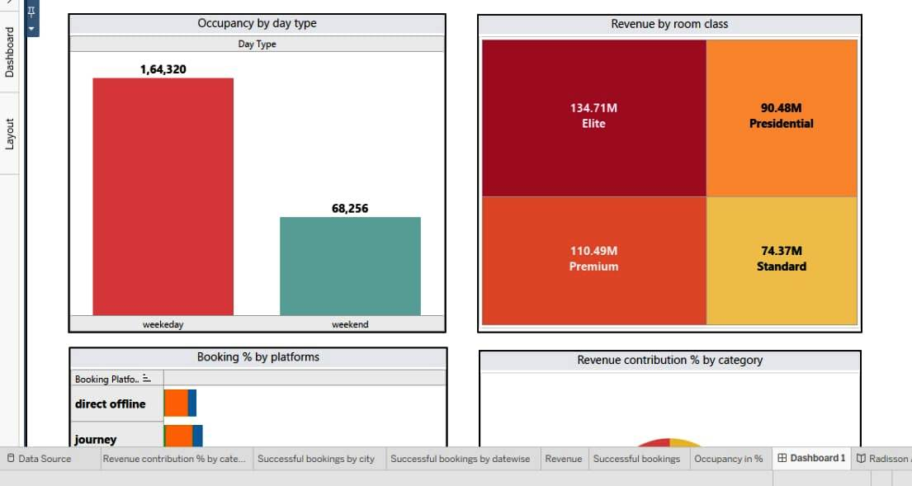

**3.3 Web Integral**

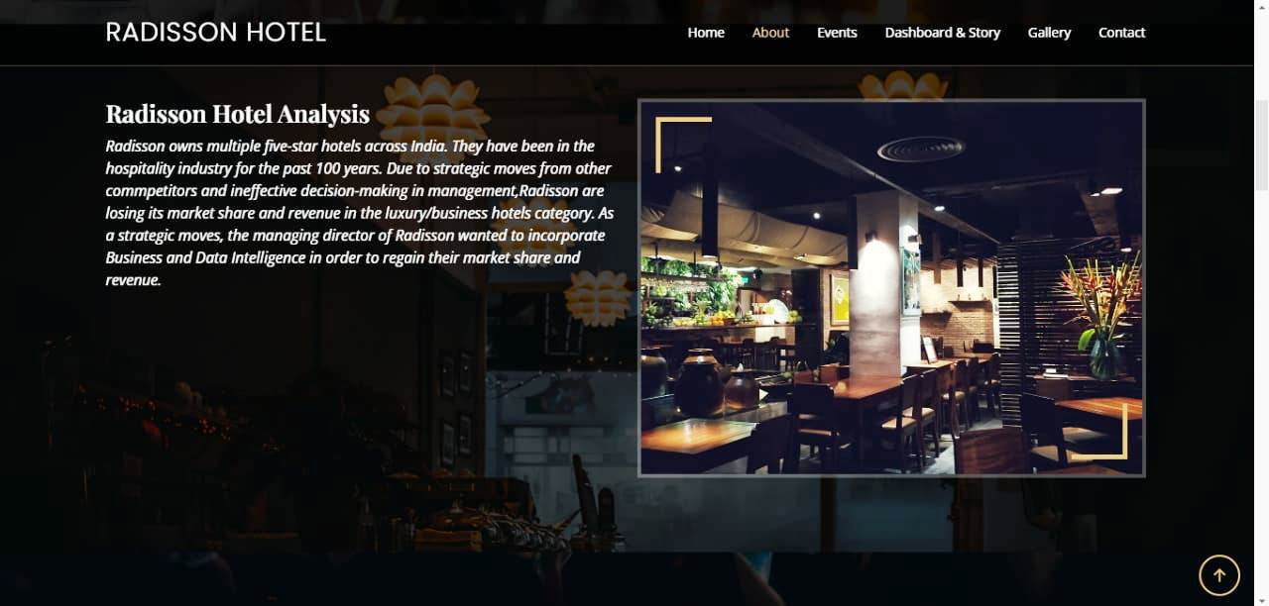

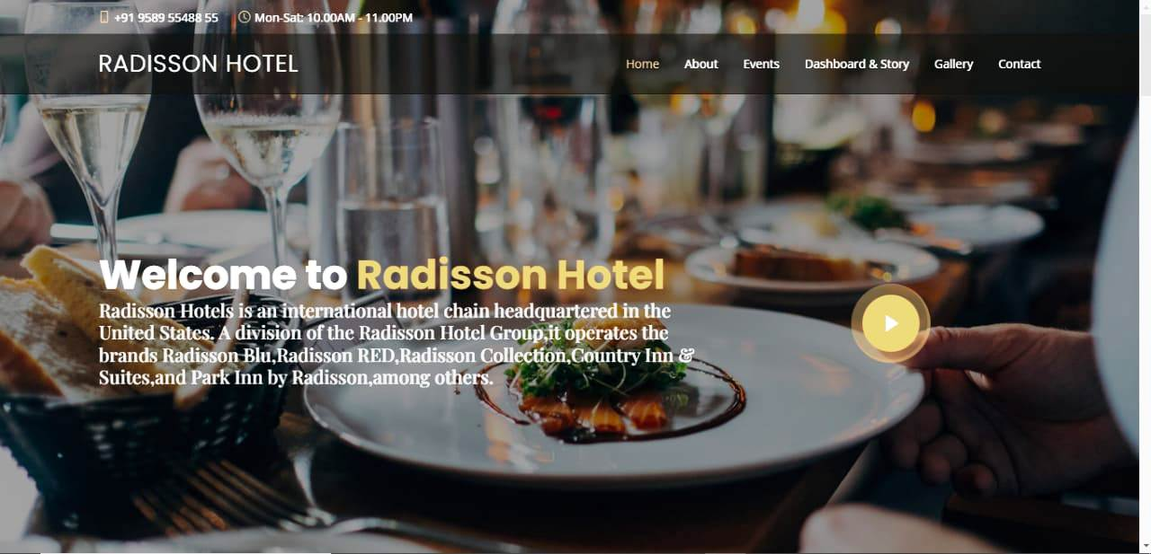

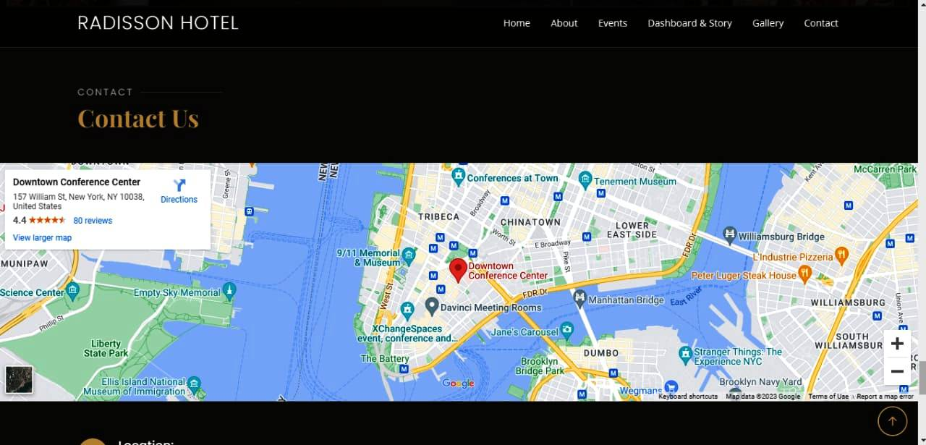

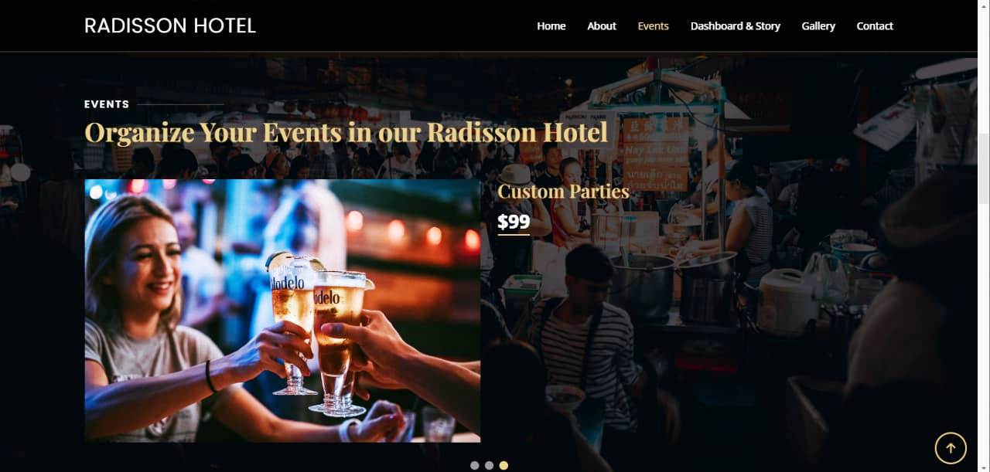

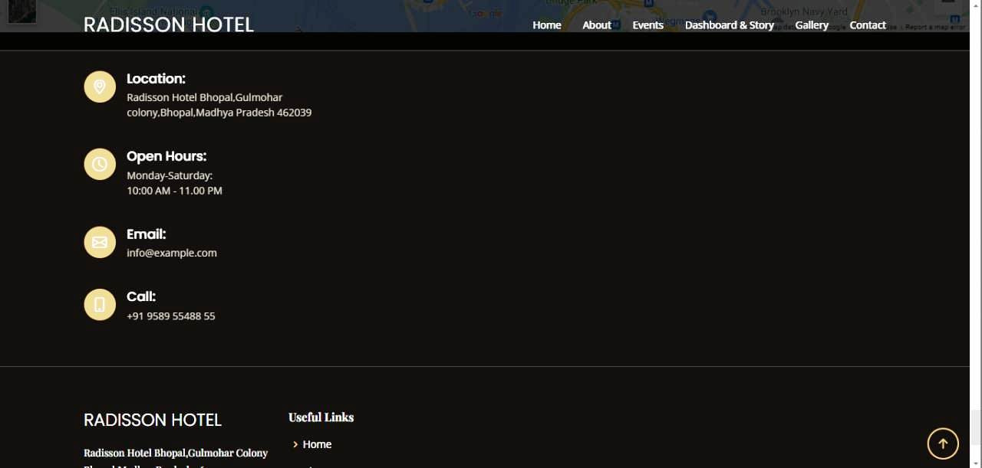

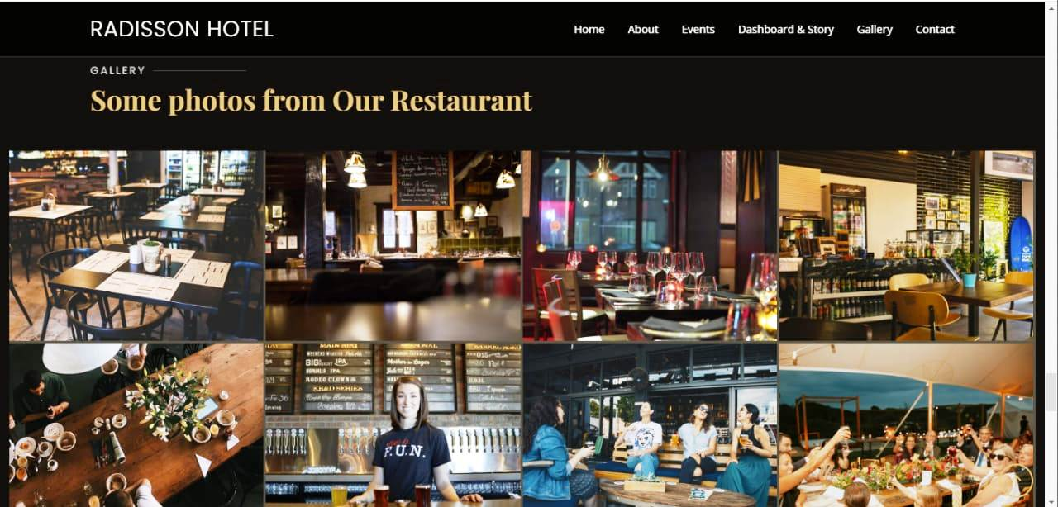

1. **Advantages and Disadvantages:**

**Advantages:**

* **Service.**
* **Wide Network.**
* **Radisson Rewards.**
* **Wide Target Segments.**
* **High Brand Recall.**

**Disadvantages:**

* **Expansion Plans.**
* **High Promotion Costs.**
* **Too Much Spread.**

1. **APPLICATIONS:**

* **Understand changes to traveler preferences to serve your customer base better.**
* **Examine previous booking patterns to help increase future occupancy rates.**
* **Compare pricing with competitors to develop an effective pricing strategy.**
* **Analyze guest spending behavior to identify your most profitable segments.**
* **Track labor costs per occupied room to identify optimal staffing levels that deliver increased guest satisfaction.**

1. **CONCLUSION:**

* **When a hotel collects detailed information derived from sources such as customer feedback forms, it can run analytics on that data about services and experiences at a hotel.**
* **Surveys of guest experiences at a hotel are also useful sources and can provide insights into booking patterns.**
* **Running analytics on such data can help hotel brands understand the strengths of their hotel and what may be working against them.**
* **Such information proves useful in helping a hospitality brand improve its offerings, find newer ways to attract customers, and boost sales.**

1. **FUTURE SCOPE:**

* **A hotel can create a comparison of rate charts based on online data of the competition's rates versus that of its brand.**
* **This can help arrive at the right discounts or offers.**

1. **APPENDIX:**

Source Code:

